SIMATS ENGINEERING
ASSESSMENT TOOL 1

COURSE NAME: Database Management Systems
COURSE CODE: CSA05

COURSE OUTCOME COVERED

CO3: Analyze relational databases using functional dependencies, normalization (1NF to 5NF), and key constraints to identify redundancy and ensure data integrity. (BL2, BL3)

Activity Tool : Experiments (High)
Assessment Tool Weightage: 40%

QUESTIONS Total Marks: 50
Q.No | Question | Bloom's Level | Marks
1 | For the relation STUDENT_COURSE(SID, SName, CID, CName, Instructor, Grade), identify all functional dependencies and determine the candidate keys. | BL2 – Understand | 5
2 | Demonstrate the process of converting an unnormalized relation into 1NF with step-by-step justification and example. | BL3 – Apply | 5
3 | Given relation R(A,B,C,D,E) with FDs: A→BC, BC→D, D→E. Analyze and decompose it to 2NF eliminating partial dependencies. | BL3 – Apply | 5
4 | Apply 3NF decomposition on the relation EMPLOYEE(EmpID, EmpName, DeptID, DeptName, ManagerID) with transitive dependencies. | BL3 – Apply | 5
5 | Verify whether R(A,B,C,D) with FDs: AB→C, C→D, D→A is in BCNF. If not, decompose it into BCNF. | BL3 – Apply | 5
6 | Experimentally verify lossless-join decomposition for a given relation using the tabular (Chase) algorithm. | BL3 – Apply | 5
7 | Identify the multi-valued dependencies in TEACHER(TID, Subject, Hobby) and decompose it into 4NF. | BL3 – Apply | 5
8 | Demonstrate how join dependencies lead to redundancy. Decompose a given relation to 5NF (Project-Join Normal Form). | BL3 – Apply | 5
9 | Given a poorly designed database schema for a college, identify all anomalies (insertion, deletion, update) and normalize it to 3NF. | BL2 – Understand | 5
10 | Compute the closure of attribute sets for the given FDs and determine all candidate keys for the relation. | BL3 – Apply | 5

Code of Conduct:

I NITTHYENDREN JS 192421180 certify that this submission is my original work and that I have adhered to the guidelines specified for this assessment.
I understand that any violation of academic integrity rules will result in disciplinary action.

Signature of the student:
NITTHYENDREN JS

RUBRICS FOR CALCULATION:

Criteria | Weightage | Level 4 – Exemplary | Level 3 – Proficient | Level 2 – Developing | Level 1 – Beginning
Understanding of Concepts | 25 | Demonstrates thorough understanding and effectively integrates multiple concepts/technologies | Good understanding with proper integration of most concepts | Basic understanding; limited or partial integration | Poor understanding; unable to integrate concepts
Experimental Design | 30 | Well-planned, systematic implementation with optimal solution | Correct implementation with minor issues | Basic implementation with errors or inefficiencies | Incorrect or incomplete implementation
Use of Tools | 20 | Effective and advanced use of tools/technologies with proper configuration | Appropriate use of tools with correct execution | Limited or inconsistent use of tools | Incorrect or minimal use of tools
Analysis of Results | 15 | Insightful analysis with accurate interpretation and validation of results | Good analysis with reasonable interpretation | Basic analysis with limited insights | Poor or incorrect analysis of results
Documentation | 10 | Clear, well-structured documentation with diagrams, code, and results | Organized documentation with necessary details | Basic documentation with missing details | Poor or incomplete documentation

ANSWERS

Q1. STUDENT_COURSE — Functional Dependencies & Candidate Keys — 5 Marks
Relation: STUDENT_COURSE(SID, SName, CID, CName, Instructor, Grade)
Functional Dependencies identified
SID -> SName
CID -> CName, Instructor
SID, CID -> Grade
Reasoning
• A student has exactly one name, so the student ID alone fixes SName: SID -> SName.
• A course has exactly one name and (assumed) one instructor, so CID -> CName, Instructor.
• Grade depends on the specific student-course PAIR, not on either alone — the same student gets different grades in different courses, and the same course gives different grades to different students, so only the composite (SID, CID) determines Grade.
Candidate key determination
Closure test: (SID, CID)+ = {SID, CID, SName, CName, Instructor, Grade} = all attributes. Neither SID alone nor CID alone can reach Grade, so the pair is minimal.
Candidate Key | Attribute Closure | Is it minimal?
{SID, CID} | All 6 attributes | Yes — smallest set covering everything
{SID} | SID, SName | No — cannot reach CName/Instructor/Grade
{CID} | CID, CName, Instructor | No — cannot reach SName/Grade

Candidate Key = {SID, CID}. Prime attributes: SID, CID. Non-prime attributes: SName, CName, Instructor, Grade.

Q2. Converting an Unnormalized Relation into 1NF — 5 Marks
Unnormalized relation (UNF) — repeating group inside one row
SID | SName | Courses
S1 | Arun | DBMS, OS, CN
S2 | Divya | DBMS, AI

This violates 1NF because the 'Courses' attribute is multi-valued — a single cell stores a comma-separated list instead of one atomic value, making it impossible to query, index, or constrain individual courses directly.
Step-by-step conversion to 1NF
• Step 1 — Identify the repeating/multi-valued attribute: Courses.
• Step 2 — Remove the repeating group by giving each (student, course) pair its own row, repeating the atomic SID/SName values as needed.
• Step 3 — Every remaining cell now holds exactly one indivisible (atomic) value, satisfying 1NF.
Resulting 1NF relation: STUDENT_COURSE(SID, SName, Course)
SID | SName | Course
S1 | Arun | DBMS
S1 | Arun | OS
S1 | Arun | CN
S2 | Divya | DBMS
S2 | Divya | AI

Justification: each row now represents a single fact (one student enrolled in one course); the table can be queried with a simple WHERE Course = 'DBMS' instead of parsing a text list.

Q3. R(A,B,C,D,E) — 2NF Decomposition Eliminating Partial Dependencies — 5 Marks
Given FDs: A -> BC, BC -> D, D -> E
Step 1 — Determine the candidate key
A+ = A -> BC -> {A,B,C}
BC -> D -> {A,B,C,D}
D -> E -> {A,B,C,D,E} (= all attributes)
A+ already equals all attributes of R, so A alone is a candidate key. No other single attribute or combination is smaller, so Candidate Key = {A}.
Step 2 — Check for partial dependency
A partial dependency can only exist when a NON-prime attribute depends on a proper SUBSET of a COMPOSITE candidate key. Here the candidate key {A} is a single attribute — it has no proper non-empty subset — so a partial dependency is structurally impossible.
Analysis / Conclusion
R(A,B,C,D,E) is therefore ALREADY in 2NF as given; no decomposition is required to remove partial dependencies, since none can exist with a single-attribute key. (Note: BC -> D and D -> E are transitive dependencies through non-prime attributes — these would need to be addressed when moving to 3NF, but that is a separate normal form from what this question asks about.)

Q4. EMPLOYEE — 3NF Decomposition Removing Transitive Dependency — 5 Marks
Relation: EMPLOYEE(EmpID, EmpName, DeptID, DeptName, ManagerID)
FDs and the transitive dependency
EmpID -> EmpName, DeptID, ManagerID
DeptID -> DeptName
EmpID -> DeptID -> DeptName is a TRANSITIVE dependency: DeptName depends on the key EmpID only indirectly, through the non-key attribute DeptID. This violates 3NF and causes redundancy — DeptName is repeated for every employee in the same department, risking inconsistent updates.
3NF Decomposition
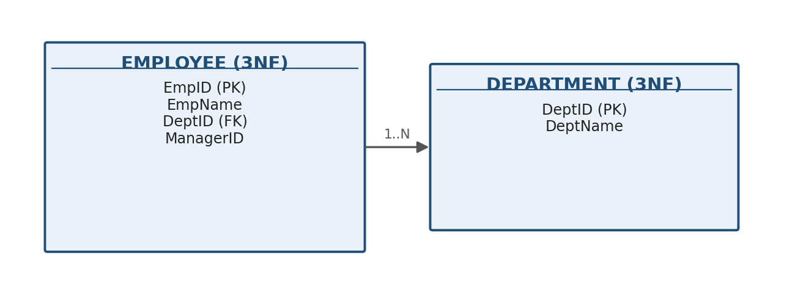

EMPLOYEE (EmpID PK, EmpName, DeptID FK -> DEPARTMENT, ManagerID)
DEPARTMENT (DeptID PK, DeptName)
Analysis: DeptName is now stored exactly once per department in DEPARTMENT. Renaming a department requires updating a single row instead of every employee row referencing it — the transitive dependency, and the update anomaly it caused, are eliminated.

Q5. R(A,B,C,D) — BCNF Verification and Decomposition — 5 Marks
Given FDs: AB -> C, C -> D, D -> A
Step 1 — Candidate keys
AB+ = A,B -> C -> D = {A,B,C,D} (full) -> AB is a candidate key
BC+ = B,C -> D -> A = {A,B,C,D} (full) -> BC is a candidate key
Candidate keys = {AB, BC}. Prime attributes: A, B, C. Non-prime attribute: D.
Step 2 — BCNF test (every determinant must be a superkey)
FD | Is determinant a candidate key? | BCNF satisfied?
AB -> C | Yes (AB is a key) | Yes
C -> D | No (C alone is not a key) | NO — violation
D -> A | No (D alone is not a key) | NO — violation

R is NOT in BCNF (two violating determinants: C and D).
Step 3 — Decompose using the violating FD C -> D
R1(C, D) -- from C -> D ; C is the key of R1 (BCNF)
R2(A, B, C) -- remaining attributes; FDs projected: AB -> C, and C -> A (transitive via C->D->A)
Step 4 — R2(A,B,C) still violates BCNF (C -> A, C is not a key of R2) — decompose again
R2a(A, C) -- from C -> A ; C is the key of R2a (BCNF)
R2b(B, C) -- remaining; no non-trivial FD -> trivially BCNF
Final BCNF decomposition
Relation | Key | BCNF?
R1(C, D) | C | Yes
R2a(A, C) | C | Yes
R2b(B, C) | {B, C} | Yes

Analysis: the join of R1, R2a, R2b on their common attribute C loslessly reconstructs R(A,B,C,D). Note the classic BCNF trade-off — the original FD AB -> C is no longer enforceable as a simple key constraint on any single decomposed relation, illustrating why BCNF guarantees a lossless join but does not always guarantee dependency preservation (unlike 3NF).

Q6. Experimental Verification of Lossless-Join Decomposition — Chase Algorithm — 5 Marks
Given: R(A,B,C,D) with FD A -> B, decomposed into R1(A,B) and R2(A,C,D).
Step 1 — Build the initial tabular (Chase) tableau — one row per decomposed relation
Row | A | B | C | D
t1 (from R1) | a1 | a2 | b13 | b14
t2 (from R2) | a1 | b22 | a3 | a4

Unsubscripted 'a' values are shared/common attributes of that relation's schema; subscripted 'b' values mark attributes NOT in that relation (temporary placeholders).
Step 2 — Apply the FD A -> B (chase rule)
Both rows agree on column A (a1 = a1), so by A -> B they MUST also agree on column B. Row t2's placeholder b22 is therefore equated to Row t1's a2.
Row | A | B | C | D
t1 | a1 | a2 | b13 | b14
t2 (after chase) | a1 | a2 | a3 | a4

Step 3 — Conclusion
Row t2 has become entirely unsubscripted (a1 a2 a3 a4) — a row consisting solely of 'a' values. Per the Chase Theorem, this proves the decomposition {R1(A,B), R2(A,C,D)} is a LOSSLESS-JOIN decomposition of R(A,B,C,D) with respect to the given FD set, because rejoining R1 and R2 will not manufacture any spurious tuple beyond the original relation.

Q7. TEACHER — Multi-Valued Dependencies & 4NF Decomposition — 5 Marks
Relation: TEACHER(TID, Subject, Hobby) — a teacher can teach several subjects AND pursue several hobbies, and the two facts are INDEPENDENT of each other.
Multi-valued dependencies identified
TID ->-> Subject
TID ->-> Hobby
Redundancy caused by the MVD (sample data)
TID | Subject | Hobby
T1 | Maths | Chess
T1 | Maths | Music
T1 | Physics | Chess
T1 | Physics | Music

Because Subject and Hobby vary independently for the same TID, EVERY subject must be paired with EVERY hobby to keep the relation consistent — 2 subjects × 2 hobbies forces 4 rows to represent facts that are really just 2 + 2 independent pieces of information.
4NF Decomposition
TEACHER_SUBJECT (TID, Subject)
TEACHER_HOBBY (TID, Hobby)
TID | Subject
T1 | Maths
T1 | Physics

TID | Hobby
T1 | Chess
T1 | Music

Analysis: splitting on the two independent multi-valued facts reduces storage from 4 rows to 2 + 2 = 4 rows here, but the saving grows multiplicatively as more subjects/hobbies are added — e.g. 5 subjects × 5 hobbies = 25 rows in TEACHER vs only 5 + 5 = 10 rows after 4NF decomposition, with zero redundancy and no risk of inconsistent partial updates.

Q8. Join Dependency, Redundancy, and 5NF (PJNF) Decomposition — 5 Marks
Classic scenario: SUPPLIER_PART_PROJECT(S, P, J) — 'if supplier S supplies part P, part P is used in project J, and supplier S supplies project J, then S must also supply part P for project J.' This circular business rule is a JOIN DEPENDENCY, not a simple FD or MVD.
Redundancy in the unnormalized combined relation
S | P | J
S1 | P1 | J1
S1 | P2 | J1
S1 | P1 | J2
S1 | P2 | J2

Every part S1 supplies must be re-listed against every project S1 supplies, even though the underlying facts are really just three independent pairwise relationships — pure redundancy caused by the 3-way join dependency *(SP, PJ, SJ).
5NF (Project-Join Normal Form) Decomposition
SP (S, P) -- supplier supplies part
PJ (P, J) -- part used in project
SJ (S, J) -- supplier supplies project
SP: S, P | PJ: P, J | SJ: S, J
S1, P1 | P1, J1 | S1, J1
S1, P2 | P1, J2 | S1, J2
 | P2, J1
 | P2, J2

Analysis: the original relation is exactly reconstructible as the 3-way NATURAL JOIN SP ⋈ PJ ⋈ SJ (this is precisely the join dependency being satisfied), but each binary relation now stores every fact exactly once — no combination is repeated, eliminating the redundancy while still allowing the full 3-way relationship to be recovered on demand.

Q9. Poorly Designed College Schema — Anomalies + 3NF Normalization — 5 Marks
Given (unnormalized) design: COLLEGE(SID, SName, DeptID, DeptName, HOD, CID, CName, Marks)
Anomalies identified
• INSERTION anomaly — a new department cannot be recorded until at least one student is enrolled in it, because DeptName/HOD only exist as columns attached to a student row.
• DELETION anomaly — deleting the last student of a department (e.g. the only student in 'Physics') erases all knowledge that the 'Physics' department and its HOD ever existed.
• UPDATE anomaly — if the HOD of a department changes, every single student row for that department must be updated; missing even one row leaves the database inconsistent.
Normalization to 3NF
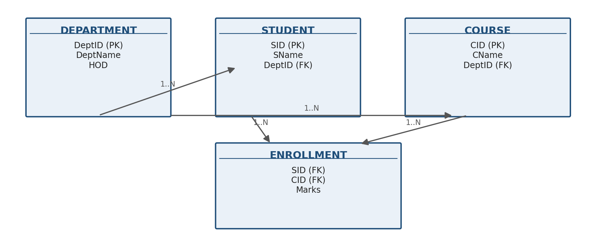

DEPARTMENT (DeptID PK, DeptName, HOD)
STUDENT (SID PK, SName, DeptID FK -> DEPARTMENT)
COURSE (CID PK, CName, DeptID FK -> DEPARTMENT)
ENROLLMENT (SID FK -> STUDENT, CID FK -> COURSE, Marks, PRIMARY KEY(SID, CID))
How each anomaly is resolved
Anomaly | Resolved by
Insertion | DEPARTMENT can be created independently, with zero students
Deletion | Deleting every STUDENT row leaves DEPARTMENT intact
Update | HOD is stored once per department in DEPARTMENT, updated in a single row

Analysis: every non-key attribute now depends only on its own table's primary key (no transitive DeptName/HOD dependency riding on SID), satisfying 3NF and removing all three anomaly classes simultaneously.

Q10. Attribute-Set Closures and Candidate Keys — 5 Marks
Given: R(A,B,C,D,E) with FDs: A -> B, B -> C, CD -> E
Step 1 — Closure of individual attributes
Attribute | Closure (+) | Full (=all 5 attrs)?
A+ | {A, B, C} (A->B, B->C) | No — missing D, E
B+ | {B, C} | No
C+ | {C} | No
D+ | {D} | No
E+ | {E} | No

Step 2 — Closure of promising attribute combinations
AD+ : start {A,D}
A -> B => {A,B,D}
B -> C => {A,B,C,D}
CD -> E (C,D present) => {A,B,C,D,E} <-- FULL SET
Step 3 — Minimality check
Subset of AD | Closure | Full?
A alone | {A,B,C} | No — cannot drop D
D alone | {D} | No — cannot drop A

Since neither proper subset of {A,D} reaches all five attributes, AD is minimal.
Conclusion
Candidate Key = {A, D} (the unique minimal attribute set whose closure is the full relation). Prime attributes: A, D. Non-prime attributes: B, C, E.

— End of Solution Key —

